Cyber Security November Minor Project

**Submitted by - NIHAL AWASTHI**

**1. Perform Foot printing on Tessla Website and gather information about website by using online Websites (Whois / netcraft / Shodan / dnsdumpster., etc.) as much as possible and write report on gathered info along with screenshots.**

**Ans:-**

**WHOIS.com**

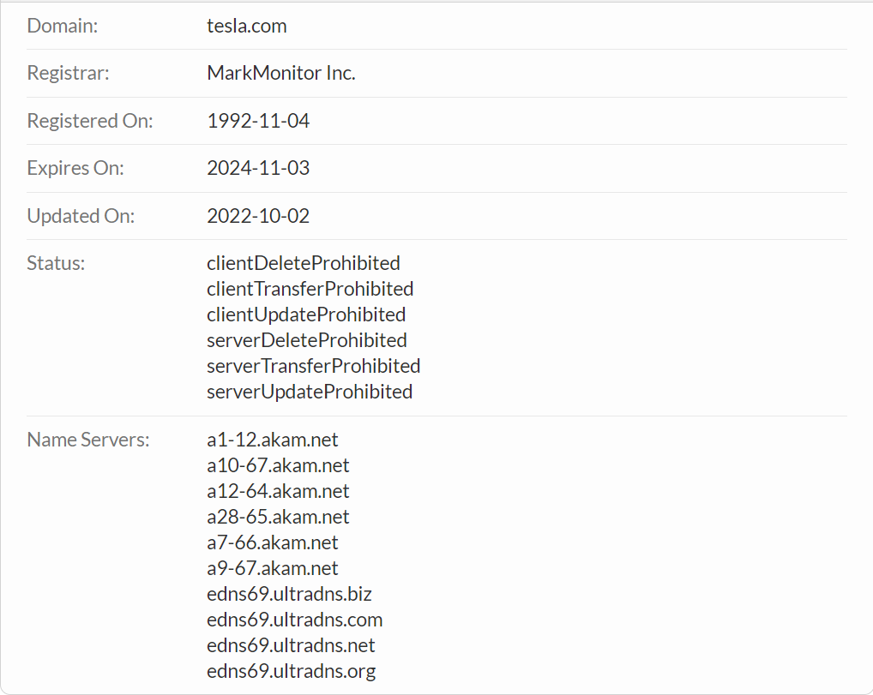**Domain Information**

**Registrant Contact**

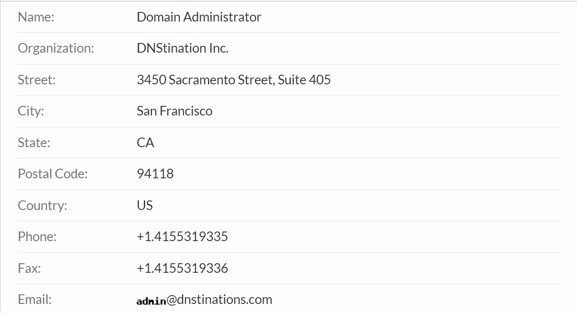

**Administrative Contact**

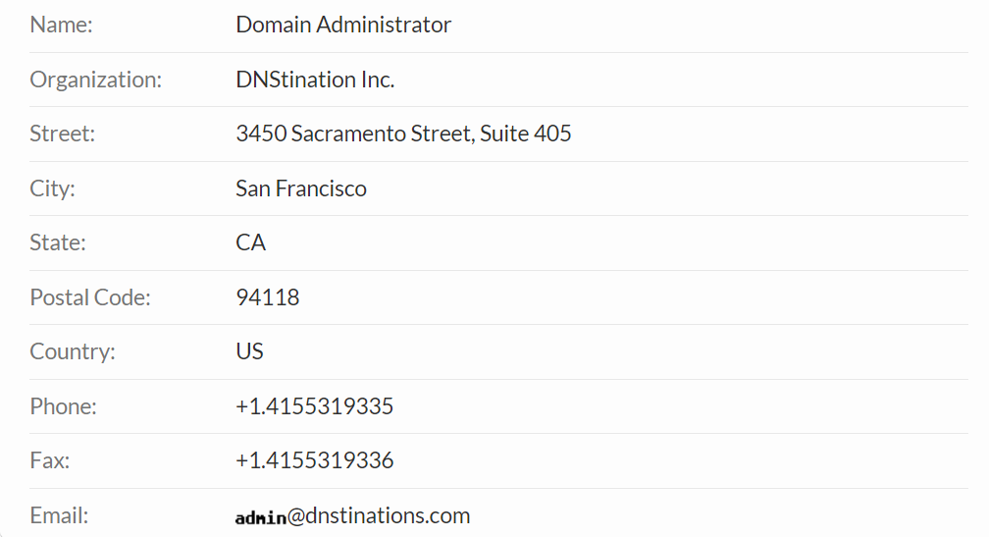

**Technical Contact**

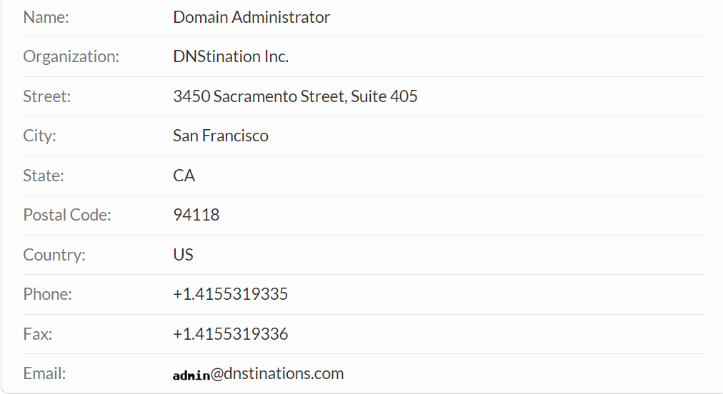

**Raw Whois Data**

Domain Name: tesla.com

Registry Domain ID: 187902_DOMAIN_COM-VRSN

Registrar WHOIS Server: whois.markmonitor.com

Registrar URL: http://www.markmonitor.com

Updated Date: 2022-10-02T09:36:05+0000

Creation Date: 1992-11-04T05:00:00+0000

Registrar Registration Expiration Date: 2024-11-03T00:00:00+0000

Registrar: MarkMonitor, Inc.

Registrar IANA ID: 292

Registrar Abuse Contact Email: @markmonitor.com

Registrar Abuse Contact Phone: +1.2086851750

Domain Status: clientUpdateProhibited (https://www.icann.org/epp#clientUpdateProhibited)

Domain Status: clientTransferProhibited (https://www.icann.org/epp#clientTransferProhibited)

Domain Status: clientDeleteProhibited (https://www.icann.org/epp#clientDeleteProhibited)

Domain Status: serverUpdateProhibited (https://www.icann.org/epp#serverUpdateProhibited)

Domain Status: serverTransferProhibited (https://www.icann.org/epp#serverTransferProhibited)

Domain Status: serverDeleteProhibited (https://www.icann.org/epp#serverDeleteProhibited)

Registry Registrant ID:

Registrant Name: Domain Administrator

Registrant Organization: DNStination Inc.

Registrant Street: 3450 Sacramento Street, Suite 405

Registrant City: San Francisco

Registrant State/Province: CA

Registrant Postal Code: 94118

Registrant Country: US

Registrant Phone: +1.4155319335

Registrant Phone Ext:

Registrant Fax: +1.4155319336

Registrant Fax Ext:

Registrant Email: @dnstinations.com

Registry Admin ID:

Admin Name: Domain Administrator

Admin Organization: DNStination Inc.

Admin Street: 3450 Sacramento Street, Suite 405

Admin City: San Francisco

Admin State/Province: CA

Admin Postal Code: 94118

Admin Country: US

Admin Phone: +1.4155319335

Admin Phone Ext:

Admin Fax: +1.4155319336

Admin Fax Ext:

Admin Email: @dnstinations.com

Registry Tech ID:

Tech Name: Domain Administrator

Tech Organization: DNStination Inc.

Tech Street: 3450 Sacramento Street, Suite 405

Tech City: San Francisco

Tech State/Province: CA

Tech Postal Code: 94118

Tech Country: US

Tech Phone: +1.4155319335

Tech Phone Ext:

Tech Fax: +1.4155319336

Tech Fax Ext:

Tech Email: @dnstinations.com

Name Server: edns69.ultradns.org

Name Server: a10-67.akam.net

Name Server: a7-66.akam.net

Name Server: a12-64.akam.net

Name Server: edns69.ultradns.net

Name Server: a28-65.akam.net

Name Server: edns69.ultradns.com

Name Server: a9-67.akam.net

Name Server: a1-12.akam.net

Name Server: edns69.ultradns.biz

DNSSEC: unsigned

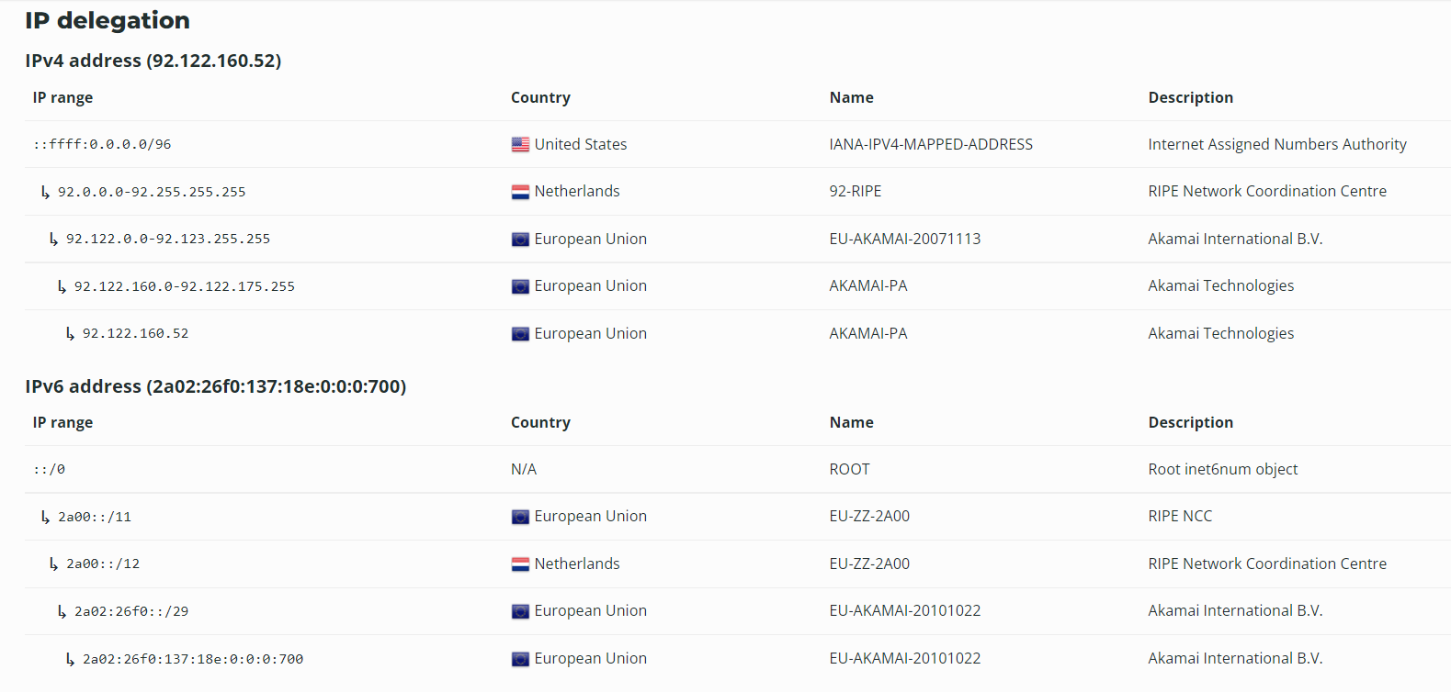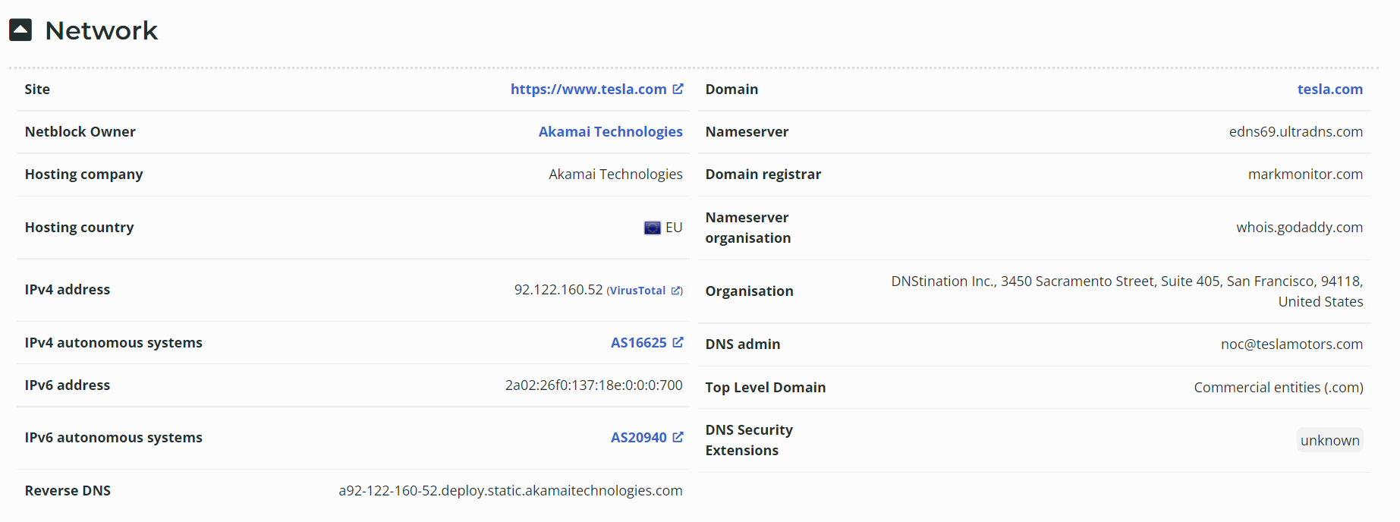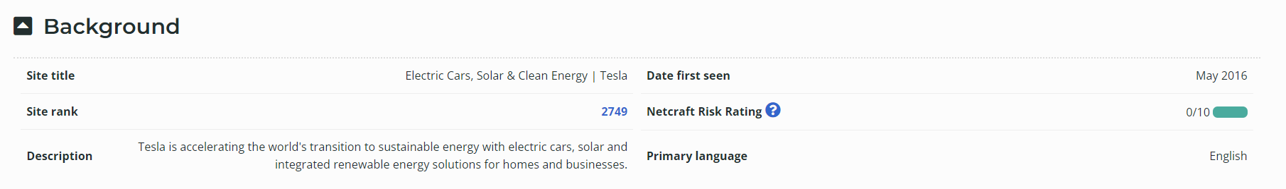**Netcraft**

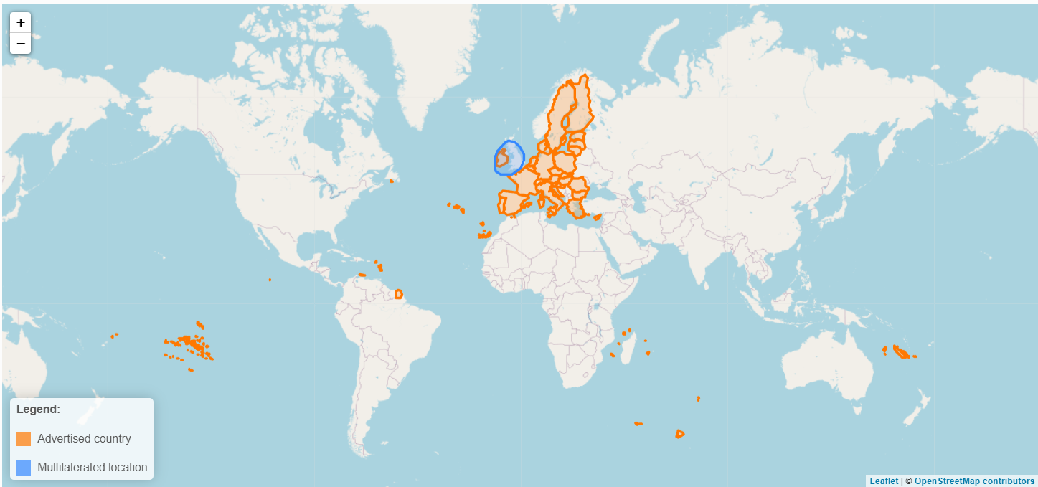**IP Geolocation**

## SSL/TLS

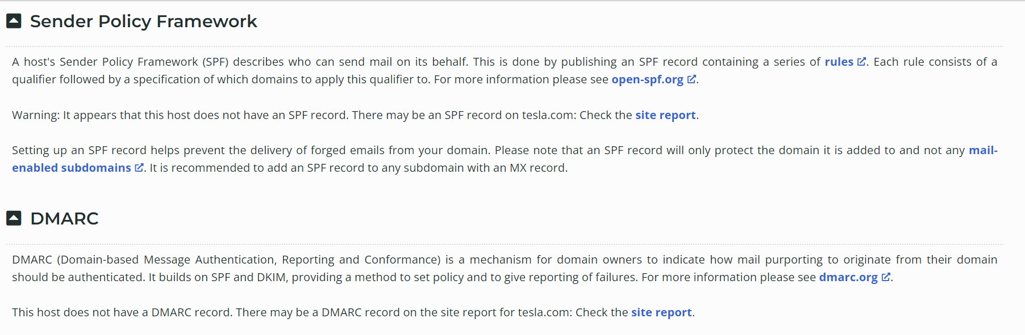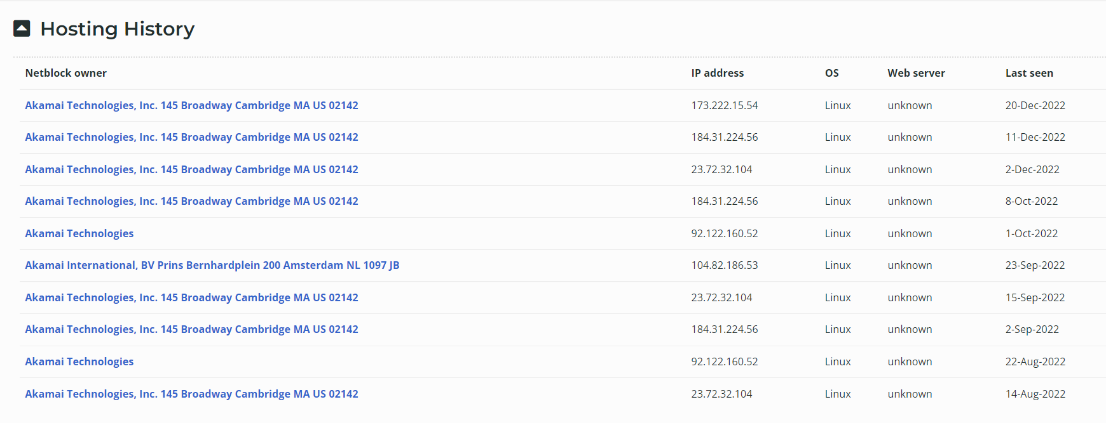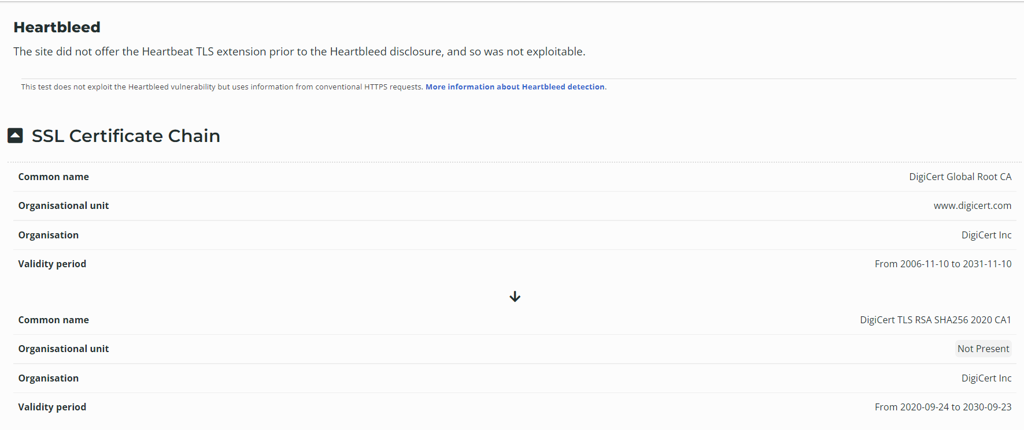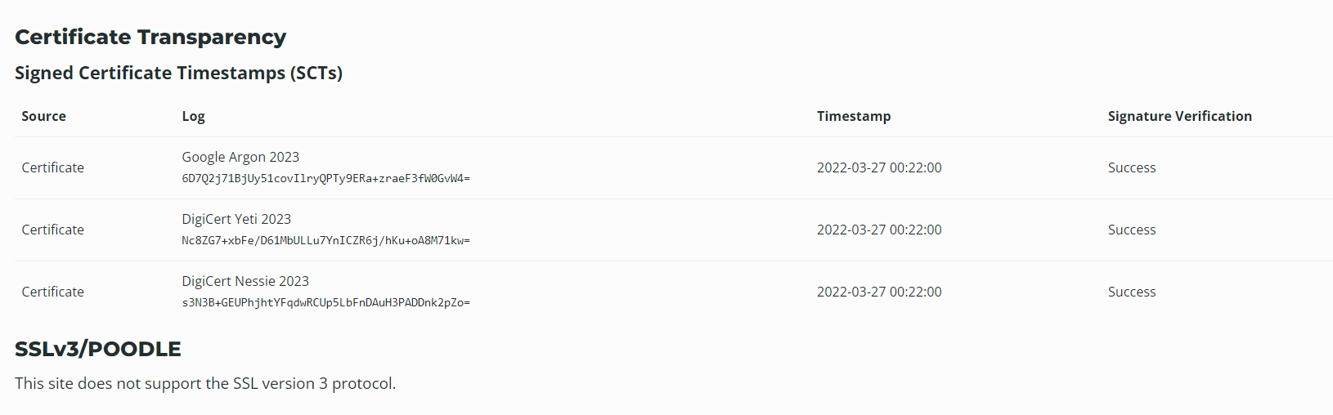

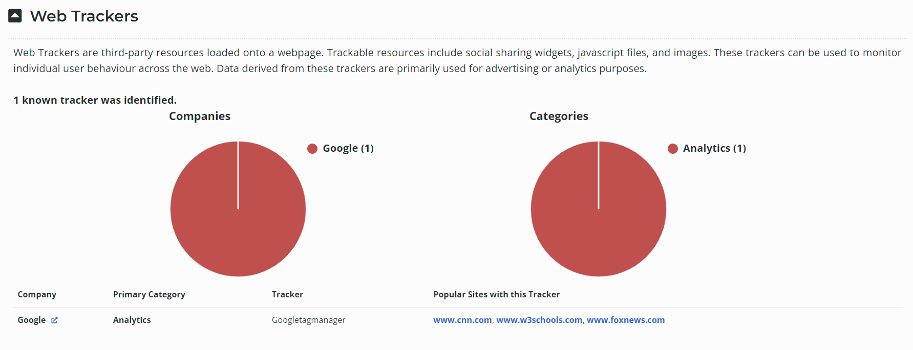

## Site Technology (fetched 10 days ago)

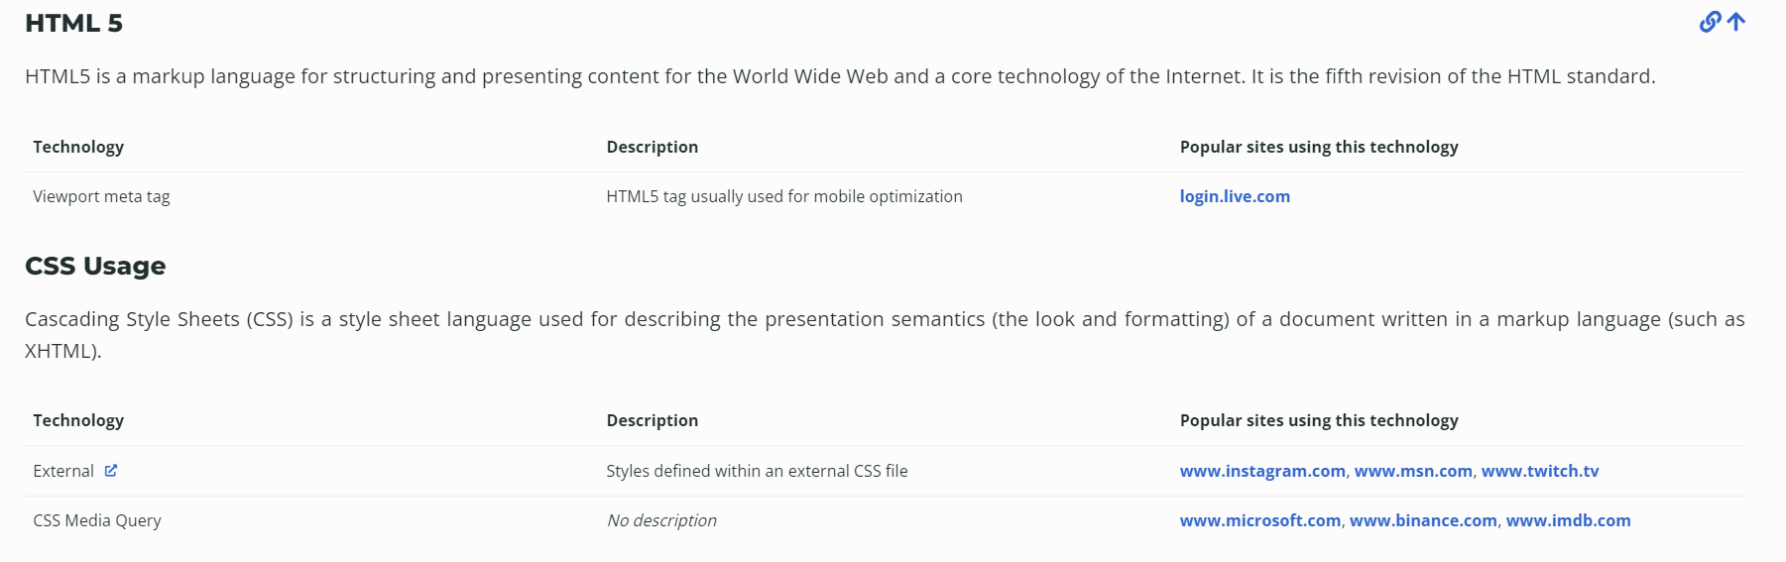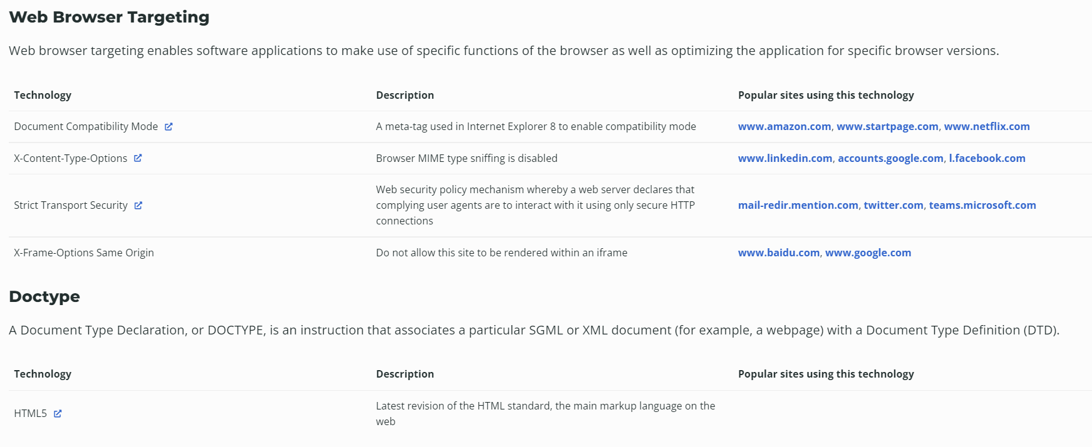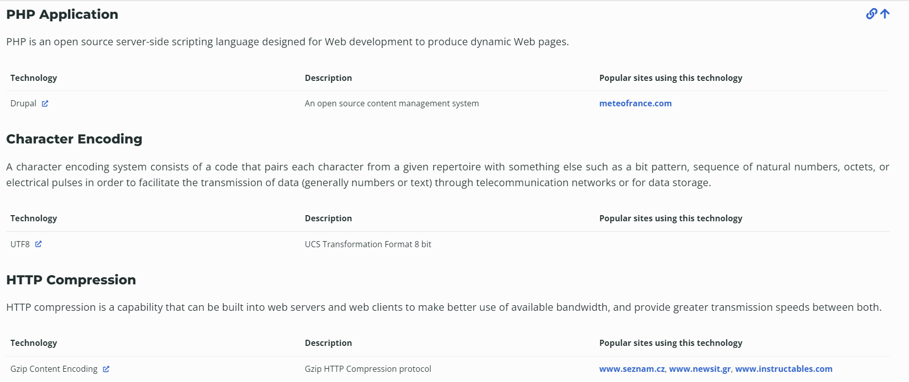

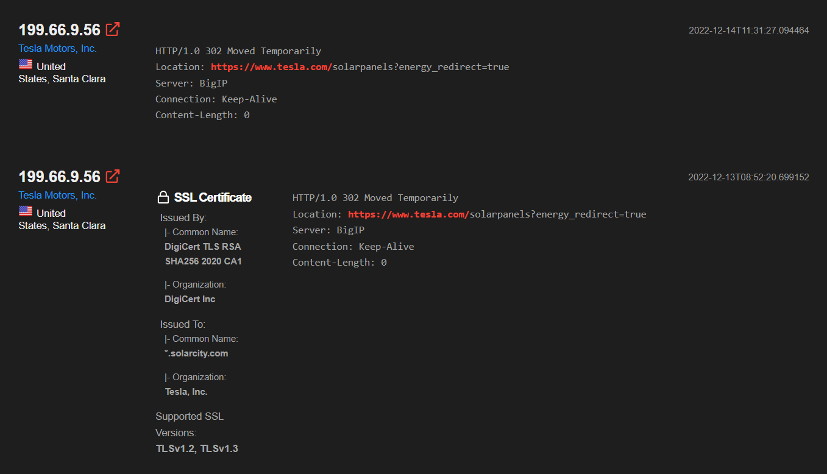**Shodan**

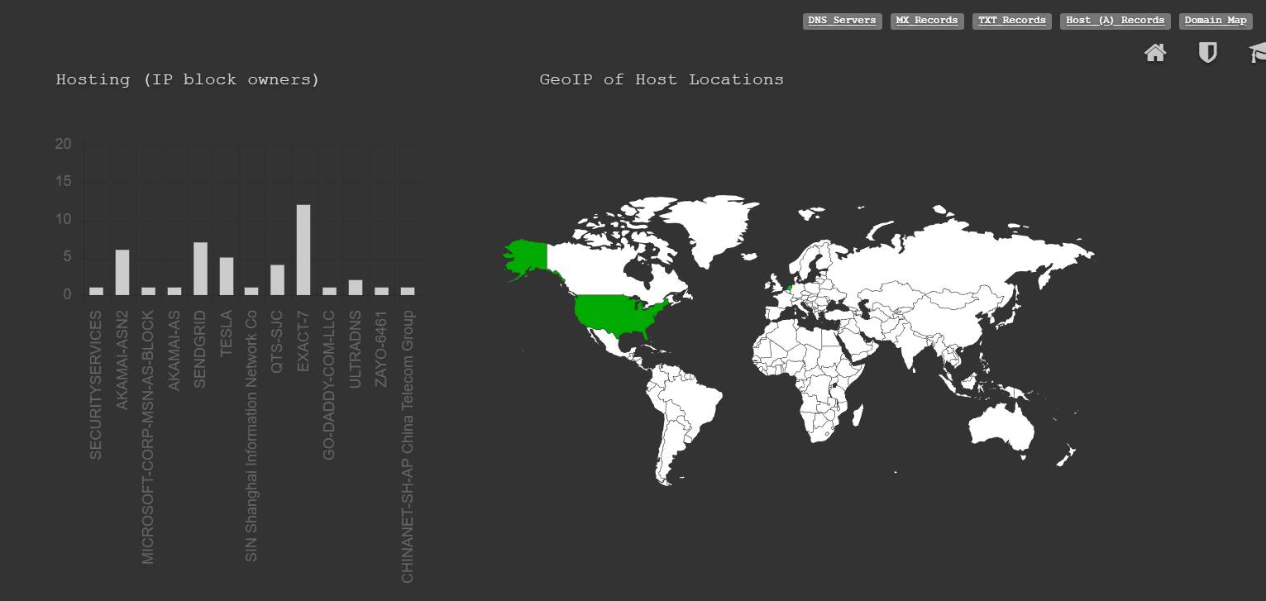dnsdumpster

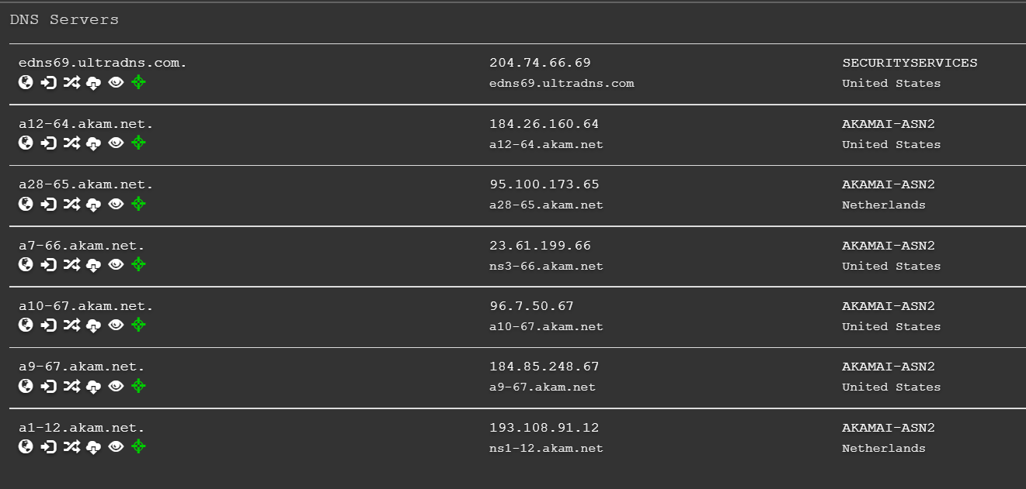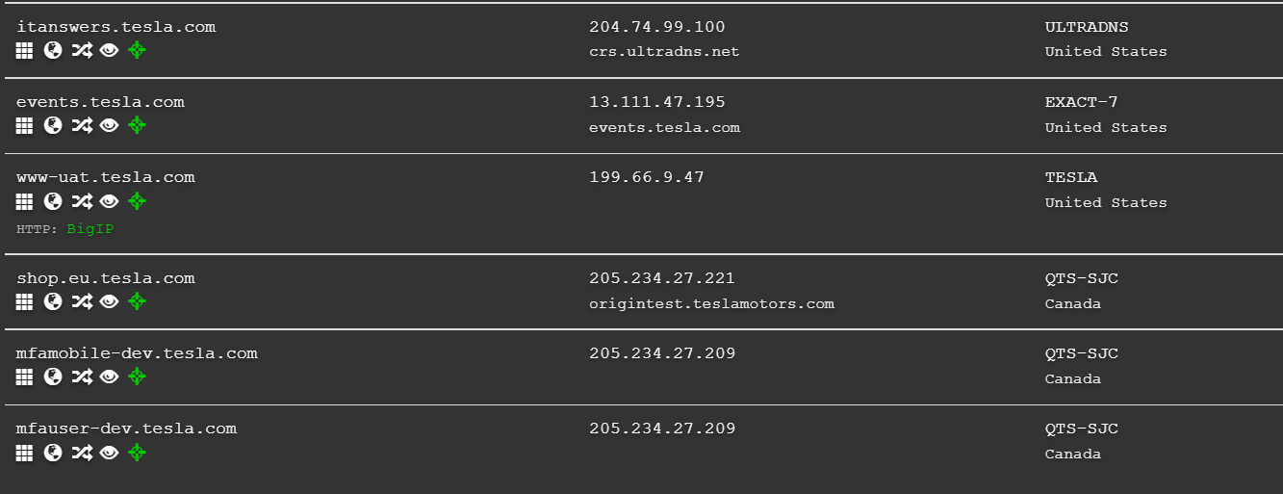

TXT Records

|  |
| --- |
| "apple-domain-verification=C9J7eOtEbm7Dqr88" |
| "SFMC-qkAv7SvlQaslp7NEALX8t68s_AZWOQB6ThKQS5l5" |
| "adobe-sign-verification=efb2da198047b7a154bd604d2721038b" |
| "teamviewer-sso-verification=2fc989f75b19494fab5eb0e2c22dd625" |
| "ms-domain-verification=e335cec9-0ff5-4a54-b8bc-8966a8d146db" |
| "zapier-domain-verification-challenge=64e810e8-0fe1-4de0-b104-229592811c5b" |
| "v=spf1 ip4:54.240.84.225/32 ip4:54.240.84.226/31 ip4:54.240.84.228/30 ip4:54.240.84.232/29 ip4:54.240.84.240/29 ip4:54.240.84.248/30 ip4:54.240.84.252/32 ip4:44.239.249.139 ip4:52.24.70.112 ip4:34.223.204.78 ip4:213.244.145.203 ip4:213.244.145.219 ip4:213" ".244.145.204 ip4:213.244.145.220 ip4:8.47.24.203 ip4:8.47.24.219 ip4:8.47.24.204 ip4:8.47.24.220 ip4:8.45.124.203 ip4:8.45.124.219 ip4:8.45.124.204 ip4:8.45.124.220 ip4:8.21.14.203 ip4:8.21.14.219 ip4:8.21.14.204 ip4:8.21.14.220 ip4:8.21.14.194 ip4:8.21.1" "4.211 ip4:212.49.145.0/24 ip4:91.103.52.0/22 ip4:168.245.123.10 ip4:216.81.144.165 ip4:149.72.247.52 ip4:149.72.134.64 ip4:149.72.152.236 ip4:149.72.163.58 ip4:149.72.172.170 ip4:167.89.90.62 ip4:158.228.129.79 ip4:216.81.144.165 ip4:117.50.14.178 ip4:117" ".50.35.199 include:u13494342.wl093.sendgrid.net include:spf.protection.outlook.com include:mail.zendesk.com include:_spfsn.teslamotors.com include:_spf.qualtrics.com include:_spf.ultipro.com include:_spf.psm.knowbe4.com -all" |
| "adobe-idp-site-verification=321c026a-3a8c-4206-a1fa-391a59585c54" |
| "google-site-verification=Y7lbse5bSatjXaqSBOWXjsit4mOp9cQzfLDpnQUSZlg" |
| "docker-verification=74d1ec4e-a7a6-48a7-9568-9bd0faac833f" |
| "T0E0S29854" |
| "logmein-domain-confirmation=9zxwVn2buGWrLtU24J88" |
| "bugcrowd-verification=40bd5dd89a6e4073ca9bc76feac3a47b" |
| "55zNJIDU0xk94IfGJtL+Hh+wje5JzOS6GY+ntggZF908AUsx0LBKgr+Nln3CgZEUifxSuN09M05jYpdbd6+cpw==" |
| "traction-guest=b4f7ad59-bf17-4b3c-8b36-9c2d28f1de32" |
| "MS=ms22358213" |

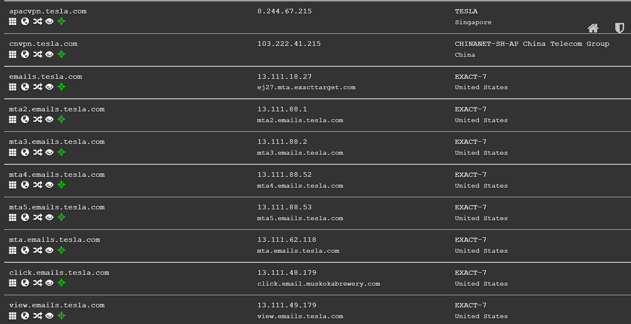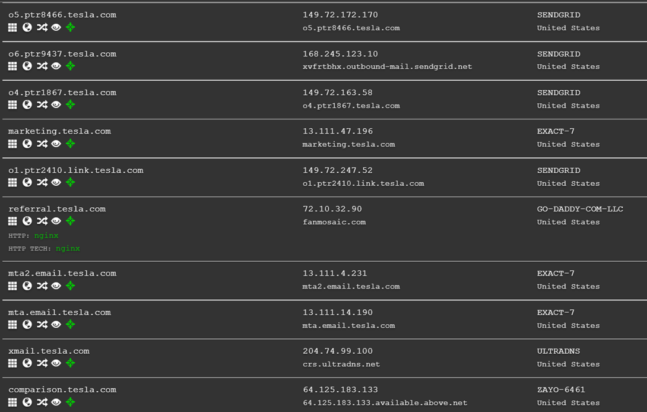

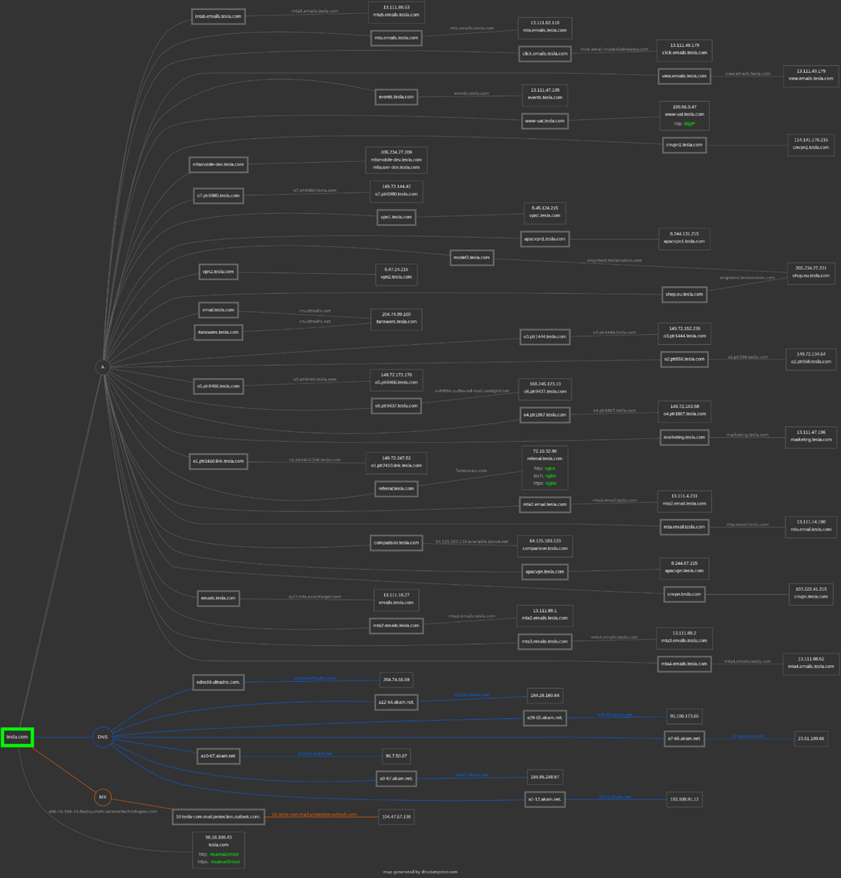Mapping the domain

**2. Perform SQL injection on http://testphp.vulnweb.com Write a report along with screenshots and mention preventive steps to avoid SQL injections.**

**Step 1.**

**Finding login page**

**http://testphp.vulnweb.com/login -- 404 page not found**

**http://testphp.vulnweb.com/adminlogin -- 404 page not found**

**http://testphp.vulnweb.com/Admin_login -- 404 page not found**

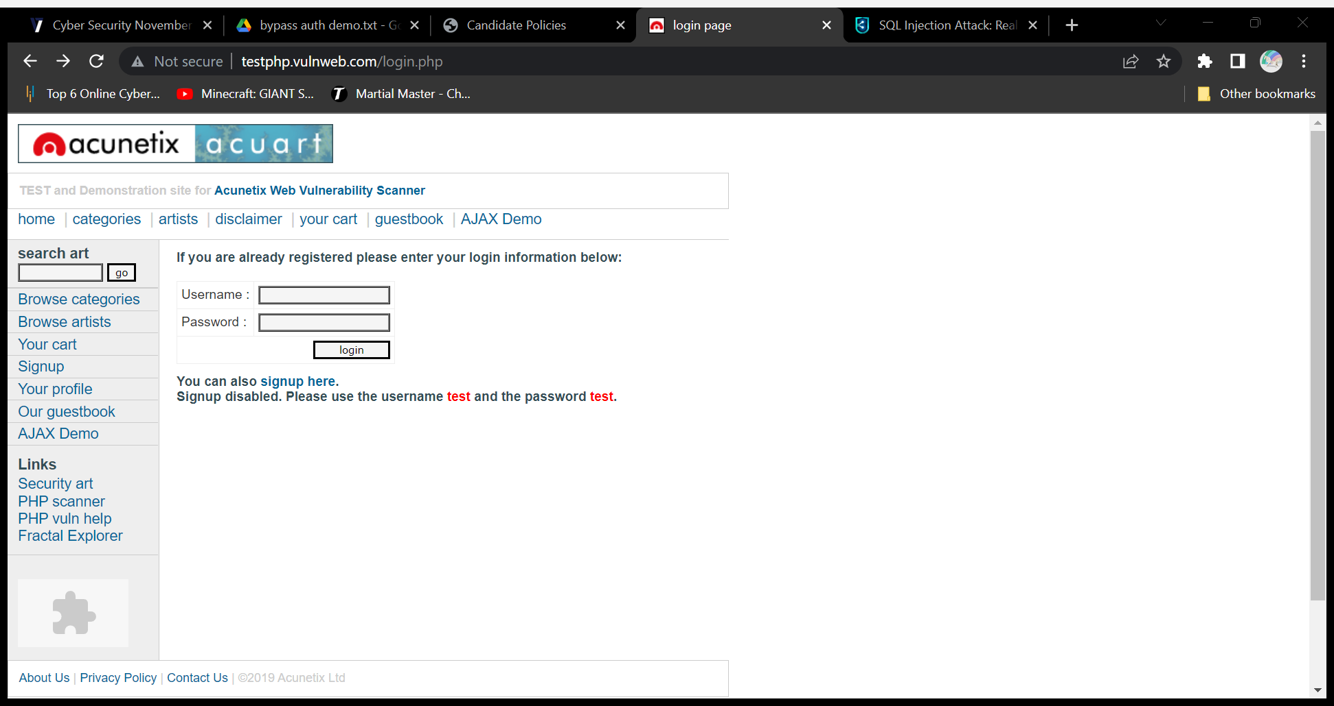**http://testphp.vulnweb.com/login.php --**

**Step 2.**

**Try default uid & pwd:**

**User id Password Result**

**admin admin Login Failed**

**admin Admin@123 Login Failed**

**admin admin@123 Login Failed**

**admin Administrator@123 Login Failed**

**root root@0000 Login Failed**

**admin xyz.com@123 Login Failed**

**Step 3.**

**Try Payloads**

**1’or’1’=’1**

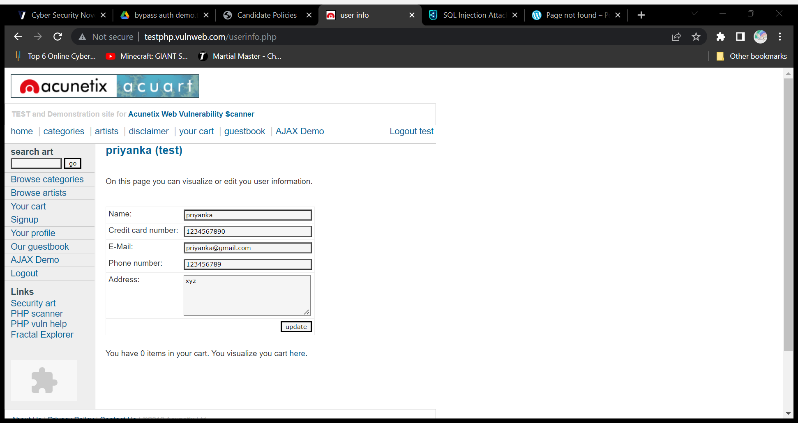

**SQL Injection(Bypass Authentication) Successful**

**Data Obtained**

**Name - Priyanka**

**Credit card no. - 1234567890**

**Email – priyanka@gmail.com**

**Phone no. - 123456789**

**Address - xyz**

**What is a SQL Injection Attack?**

SQL Injection attacks (or SQLi) alter SQL queries, injecting malicious code by exploiting application vulnerabilities.

Successful SQLi attacks allow attackers to modify database information, access sensitive data, execute admin tasks on the database, and recover files from the system. In some cases attackers can issue commands to the underlying database operating system.

**Impact of SQL injection on your applications:**

* **Steal credentials**—attackers can obtain credentials via SQLi and then impersonate users and use their privileges.
* **Access databases**—attackers can gain access to the sensitive data in database servers.
* **Alter data**—attackers can alter or add new data to the accessed database.
* **Delete data**—attackers can delete database records or drop entire tables.
* **Lateral movement**—attackers can access database servers with operating system privileges, and use these permissions to access other sensitive systems.

## Preventing SQL Injection Attack

* **Keep all web application software components including libraries, plug-ins, frameworks, web server software, and database server software up to date with the latest security patches available from vendors.**
* **Do not use shared database accounts between different web sites or applications.**
* **Validate user-supplied input for expected data types, including input fields like drop-down menus or radio buttons, not just fields that allow users to type in input.**
* **In this case :-**
  + - **Restrict speical charaters in username field except ‘@’ and ‘.’**
    - **Data has to be encrypted in DB -- it should check for hashes not with logic.**

**3. Clone a Facebook page and try to perform Desktop Phishing in your local machine and capture the credentials and write the document along with screenshots and suggest the solution to avoid from phishing.**

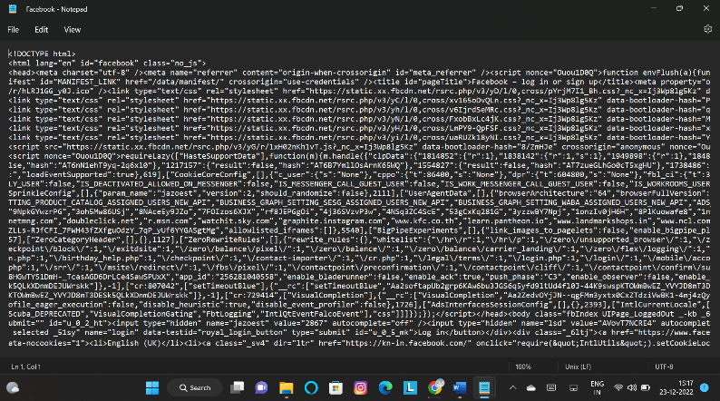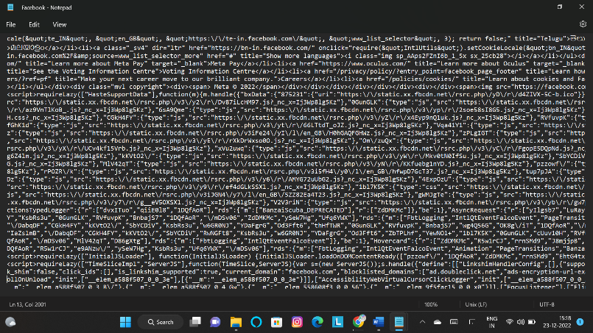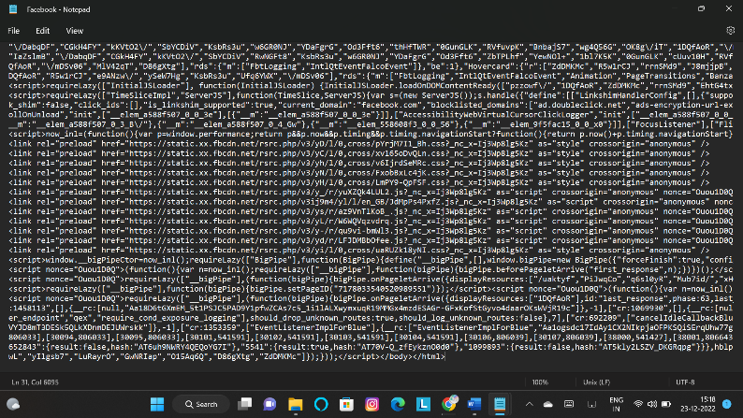**Index.html (text view)**

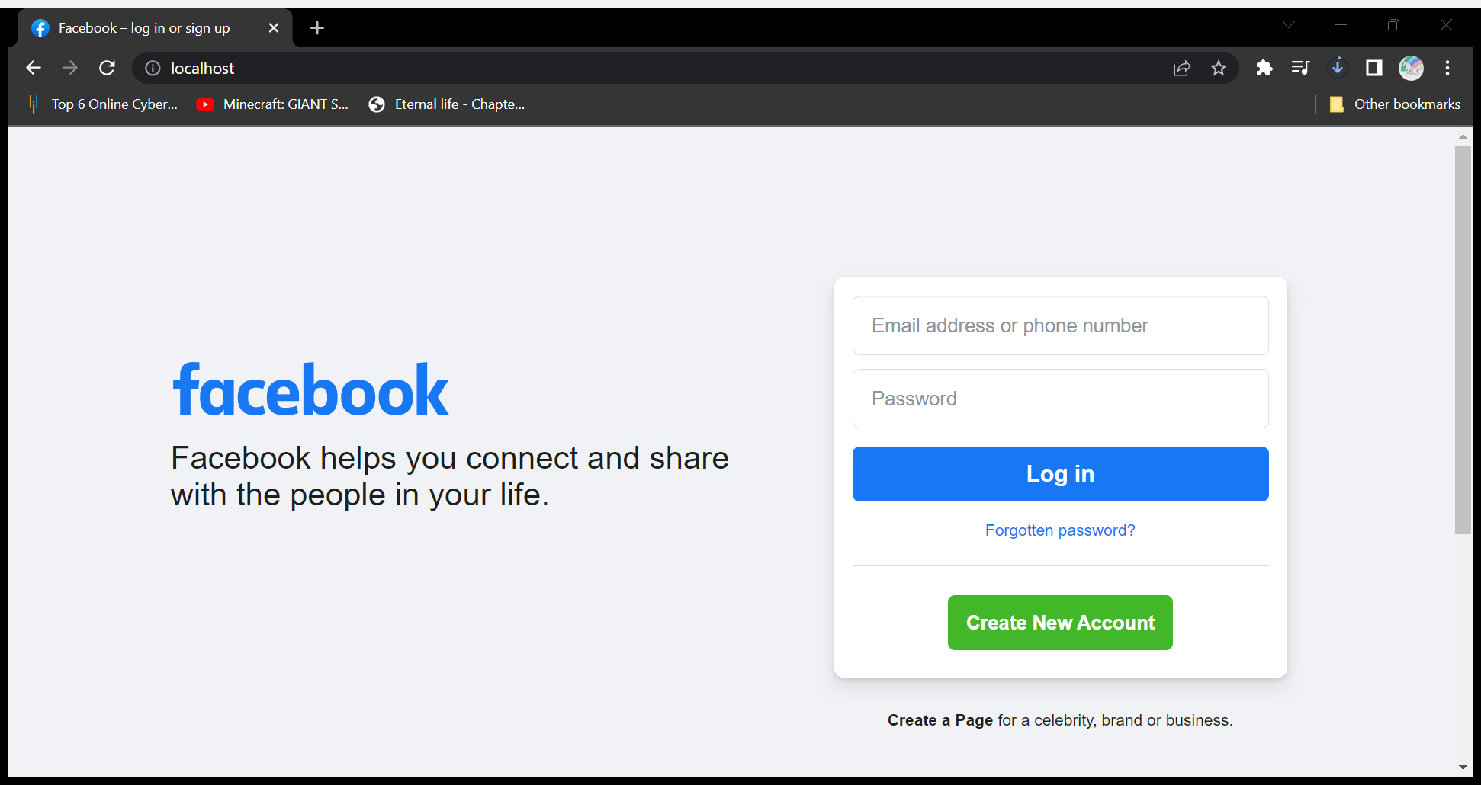**Index.html (wamp64 view)**

**Facebook.php (text view)**

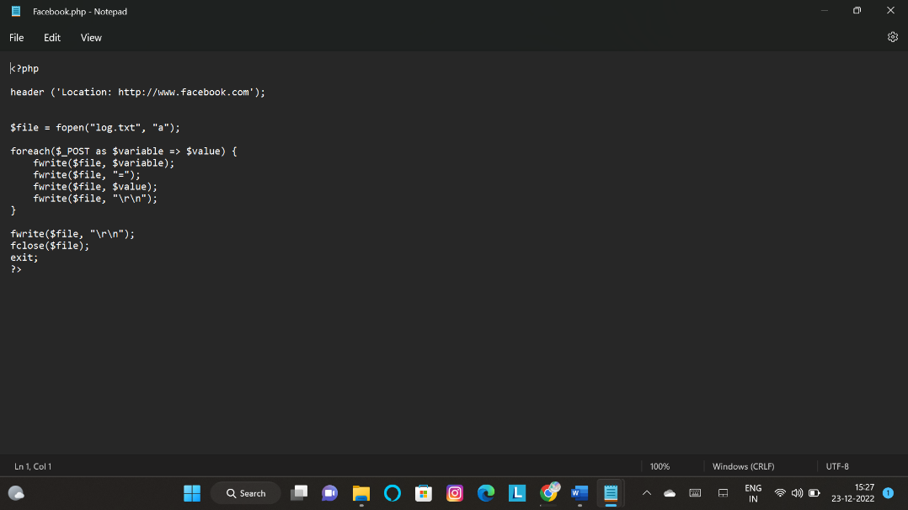

**Log.txt (Prior Phishing)**

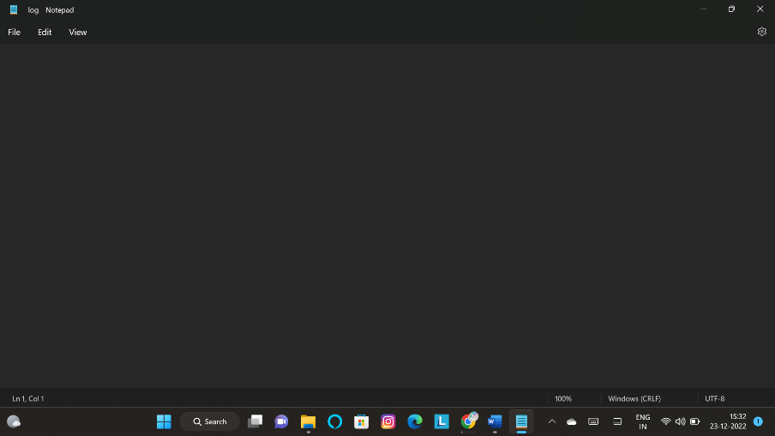

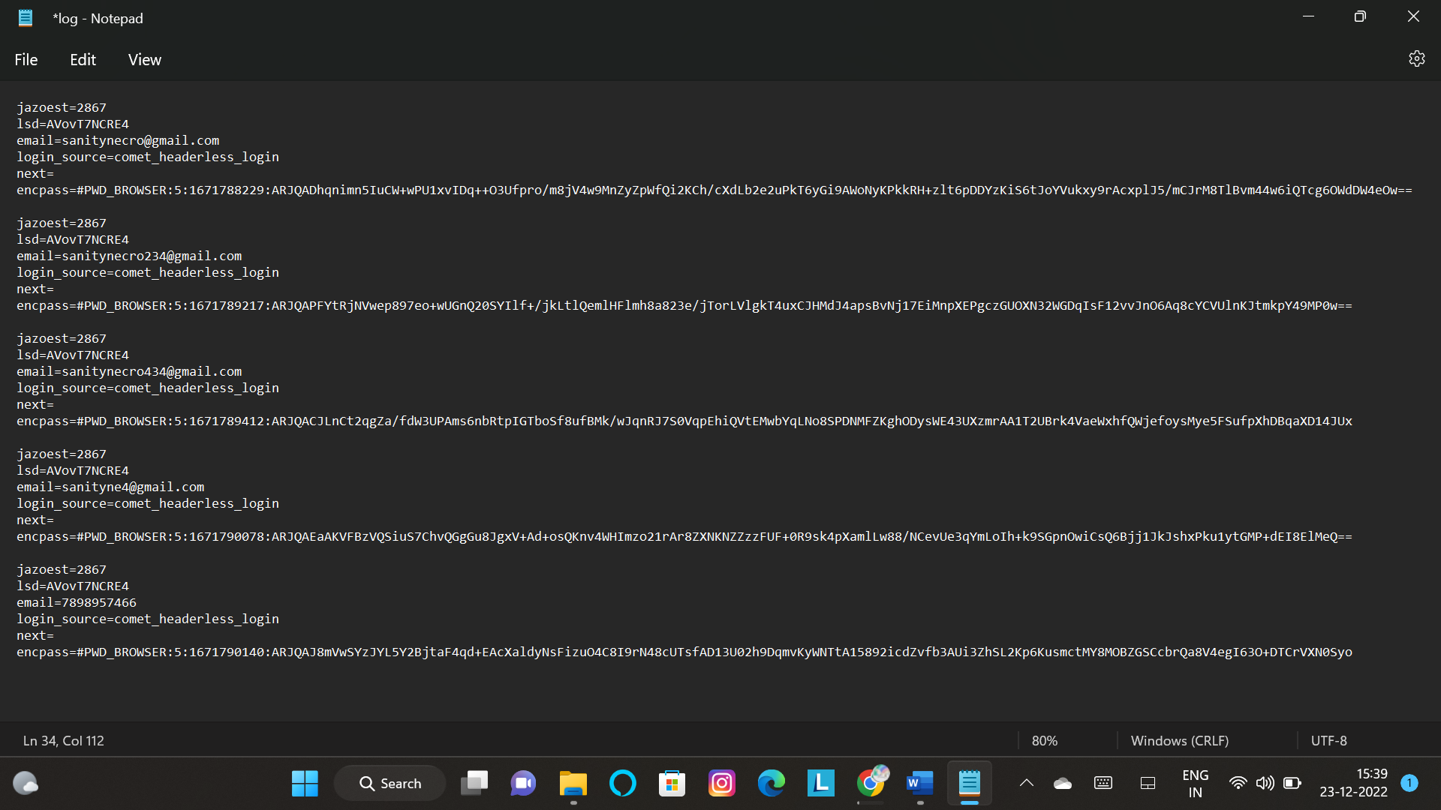**Log.txt (After Phishing)**

**Acquired login id/pass**

**1.**

**Email = sanitynecro@gmail.com**

**encpass=#PWD_BROWSER:5:1671788229:ARJQADhqnimn5IuCW+wPU1xvIDq++O3Ufpro/m8jV4w9MnZyZpWfQi2KCh/cXdLb2e2uPkT6yGi9AWoNyKPkkRH+zlt6pDDYzKiS6tJoYVukxy9rAcxplJ5/mCJrM8TlBvm44w6iQTcg6OWdDW4eOw==**

**2.**

**Email = sanitynecro234@gmail.com**

**encpass=#PWD_BROWSER:5:1671789217:ARJQAPFYtRjNVwep897eo+wUGnQ20SYIlf+/jkLtlQemlHFlmh8a823e/jTorLVlgkT4uxCJHMdJ4apsBvNj17EiMnpXEPgczGUOXN32WGDqIsF12vvJnO6Aq8cYCVUlnKJtmkpY49MP0w==**

**3.**

**Email = sanitynecro434@gmail.com**

**encpass=#PWD_BROWSER:5:1671789412:ARJQACJLnCt2qgZa/fdW3UPAms6nbRtpIGTboSf8ufBMk/wJqnRJ7S0VqpEhiQVtEMwbYqLNo8SPDNMFZKghODysWE43UXzmrAA1T2UBrk4VaeWxhfQWjefoysMye5FSufpXhDBqaXD14JUx**

**4.**

**Email = sanityne4@gmail.com**

**encpass=#PWD_BROWSER:5:1671790078:ARJQAEaAKVFBzVQSiuS7ChvQGgGu8JgxV+Ad+osQKnv4WHImzo21rAr8ZXNKNZZzzFUF+0R9sk4pXamlLw88/NCevUe3qYmLoIh+k9SGpnOwiCsQ6Bjj1JkJshxPku1ytGMP+dEI8ElMeQ==**

**5.**

**email=7898957466**

**encpass=#PWD_BROWSER:5:1671790140:ARJQAJ8mVwSYzJYL5Y2BjtaF4qd+EAcXaldyNsFizuO4C8I9rN48cUTsfAD13U02h9DqmvKyWNTtA15892icdZvfb3AUi3ZhSL2Kp6KusmctMY8MOBZGSCcbrQa8V4egI63O+DTCrVXN0Syo**

* Solution to avoid from phishing

**1. Keep Informed About Phishing Techniques** – New phishing scams are being developed all the time. Without staying on top of these new phishing techniques, you could inadvertently fall prey to one. Keep your eyes peeled for news about new phishing scams. By finding out about them as early as possible, you will be at much lower risk of getting snared by one. For IT administrators, ongoing [security awareness training](https://www.knowbe4.com/?hsLang=en&__hstc=59035826.ed4a956b6d392468ad368716a4191cc8.1671790650567.1671790650567.1671790650567.1&__hssc=59035826.1.1671790650568&__hsfp=3382678588) and [simulated phishing](https://www.phishing.org/phishing-security-test?hsLang=en) for all users is highly recommended in keeping security top of mind throughout the organization.  
  
**2. Think Before You Click!** – It’s fine to click on links when you’re on trusted sites. Clicking on links that appear in random emails and instant messages, however, isn’t such a smart move. Hover over links that you are unsure of before clicking on them. Do they lead where they are supposed to lead? A phishing email may claim to be from a legitimate company and when you click the link to the website, it may look exactly like the real website. The email may ask you to fill in the information but the email may not contain your name. Most phishing emails will start with “Dear Customer” so you should be alert when you come across these emails. When in doubt, go directly to the source rather than clicking a potentially dangerous link.  
  
**3. Install an Anti-Phishing Toolbar** – Most popular Internet browsers can be customized with anti-phishing toolbars. Such toolbars run quick checks on the sites that you are visiting and compare them to lists of known phishing sites. If you stumble upon a malicious site, the toolbar will alert you about it. This is just one more layer of protection against phishing scams, and it is completely free.  
  
**4. Verify a Site’s Security –**It’s natural to be a little wary about supplying sensitive financial information online. As long as you are on a secure website, however, you shouldn’t run into any trouble. Before submitting any information, make sure the site’s URL begins with “https” and there should be a closed lock icon near the address bar. Check for the site’s security certificate as well. If you get a message stating a certain website may contain malicious files, do not open the website. Never download files from suspicious emails or websites. Even search engines may show certain links which may lead users to a phishing webpage which offers low cost products. If the user makes purchases at such a website, the credit card details will be accessed by cybercriminals.   
  
**5. Check Your Online Accounts Regularly** – If you don’t visit an online account for a while, someone could be having a field day with it. Even if you don’t technically need to, check in with each of your online accounts on a regular basis. Get into the habit of changing your passwords regularly too. To prevent bank phishing and credit card phishing scams, you should personally check your statements regularly. Get monthly statements for your financial accounts and check each and every entry carefully to ensure no fraudulent transactions have been made without your knowledge.  
  
**6. Keep Your Browser Up to Date** – Security patches are released for popular browsers all the time. They are released in response to the security loopholes that phishers and other hackers inevitably discover and exploit. If you typically ignore messages about updating your browsers, stop. The minute an update is available, download and install it.  
  
**7. Use Firewalls** – High-quality firewalls act as buffers between you, your computer and outside intruders. You should use two different kinds: a desktop firewall and a network firewall. The first option is a type of software, and the second option is a type of hardware. When used together, they drastically reduce the odds of hackers and phishers infiltrating your computer or your network.  
  
**8. Be Wary of Pop-Ups** – Pop-up windows often masquerade as legitimate components of a website. All too often, though, they are phishing attempts. Many popular browsers allow you to block pop-ups; you can allow them on a case-by-case basis. If one manages to slip through the cracks, don’t click on the “cancel” button; such buttons often lead to phishing sites. Instead, click the small “x” in the upper corner of the window.  
  
**9. Never Give Out Personal Information** – As a general rule, you should never share personal or financially sensitive information over the Internet. This rule spans all the way back to the days of America Online, when users had to be warned constantly due to the success of early phishing scams. When in doubt, go visit the main website of the company in question, get their number and give them a call. Most of the phishing emails will direct you to pages where entries for financial or personal information are required. An Internet user should never make confidential entries through the links provided in the emails. Never send an email with sensitive information to anyone. Make it a habit to check the address of the website. A secure website always starts with “https”.  
  
**10. Use Antivirus Software** – There are plenty of reasons to use antivirus software. Special signatures that are included with antivirus software guard against known technology workarounds and loopholes. Just be sure to keep your software up to date. New definitions are added all the time because new scams are also being dreamed up all the time. Anti-spyware and firewall settings should be used to prevent phishing attacks and users should update the programs regularly. Firewall protection prevents access to malicious files by blocking the attacks. Antivirus software scans every file which comes through the Internet to your computer. It helps to prevent damage to your system.

You don’t have to live in fear of phishing scams. By keeping the preceding tips in mind, you should be able to enjoy a worry-free online experience.

**There is no single fool-proof way to avoid phishing attacks.**

4. Use SET toolkit to perform automation task on phishing and capture the details and write a report on this attack and protection from social engineering attacks.

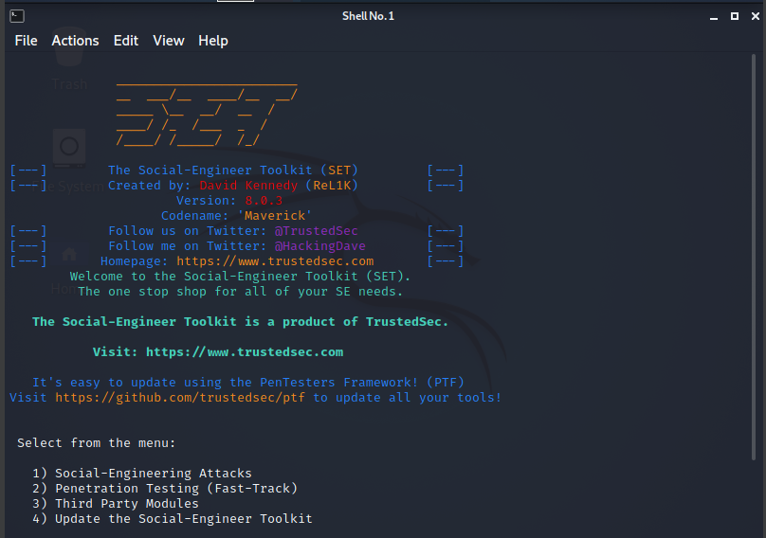Kali linux startup

Pressing 1

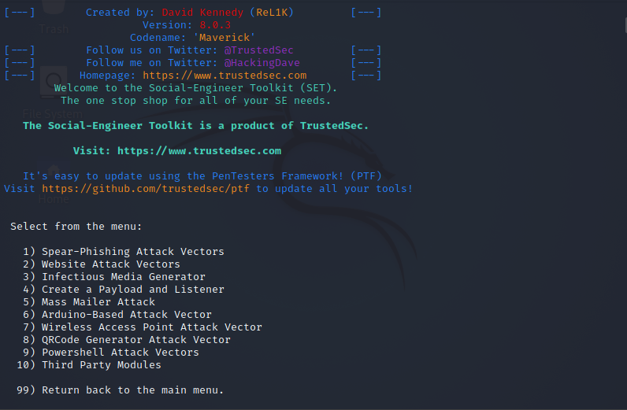

Pressing 2

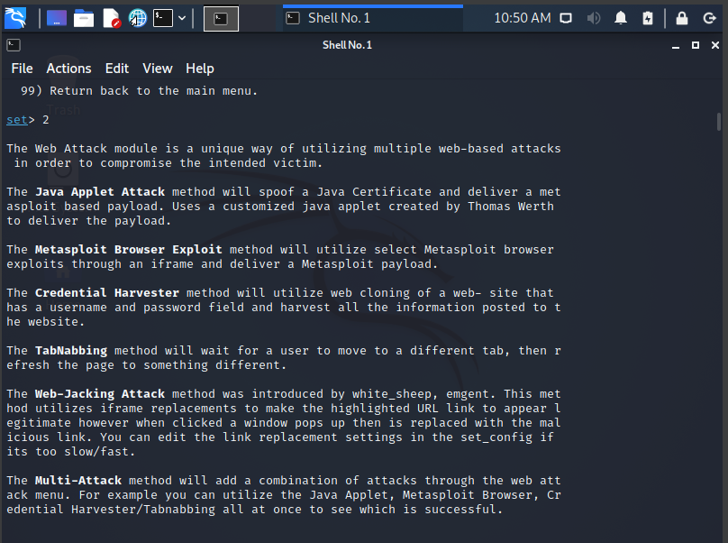

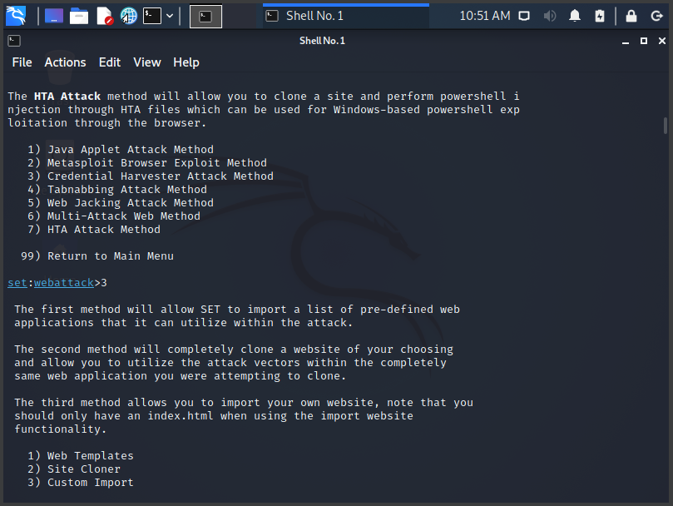

Pressing 3

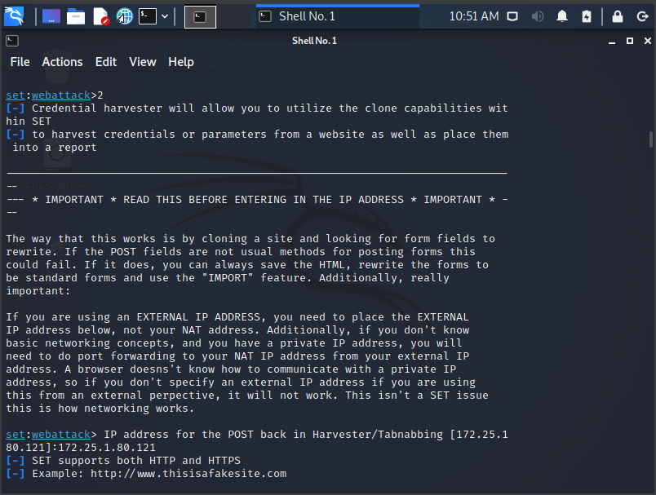

Pressing 2

Entering Ip Address:

172.25.180.121

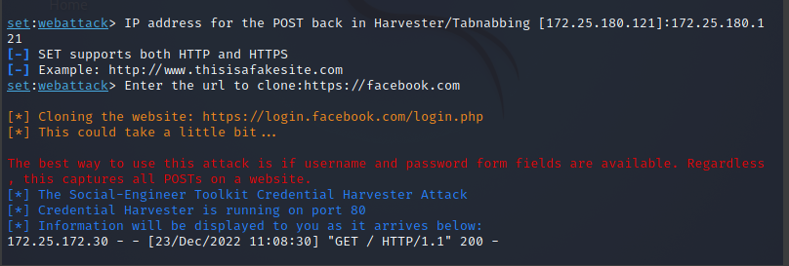

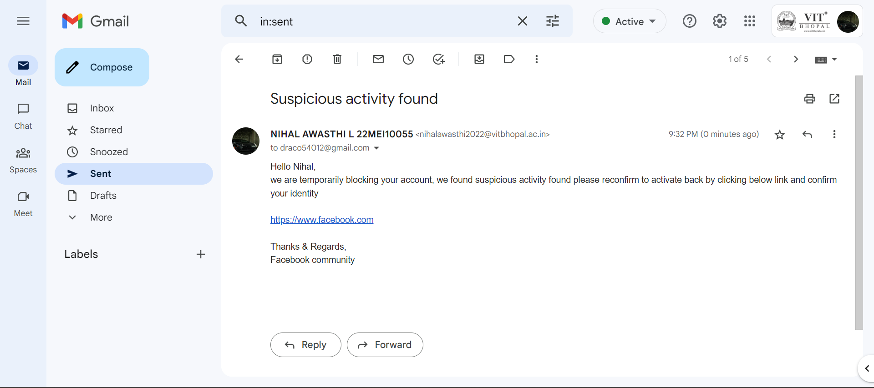Now sending a Phishing mail

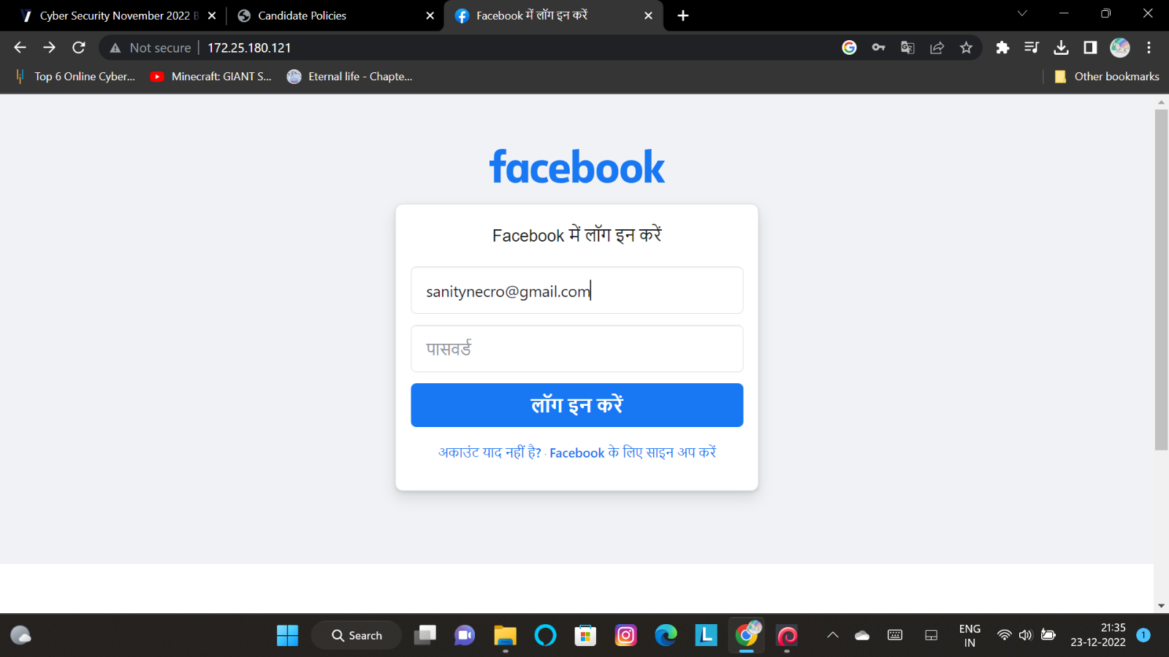Phishing Facebook page

Harvest:

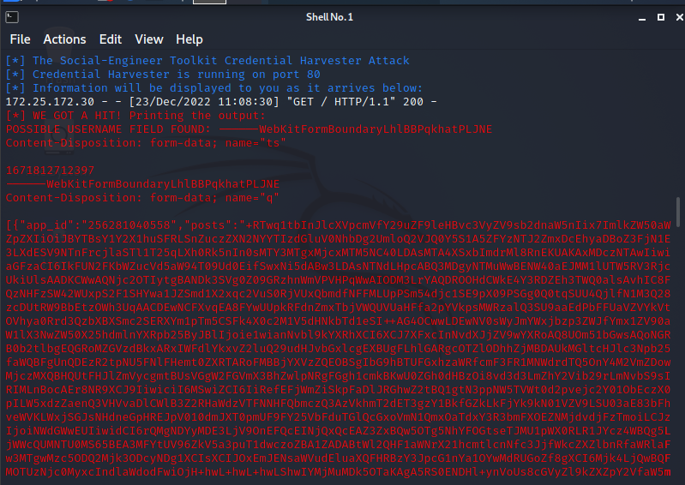

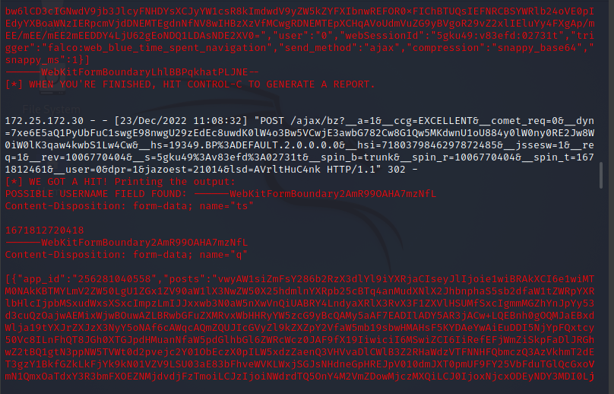

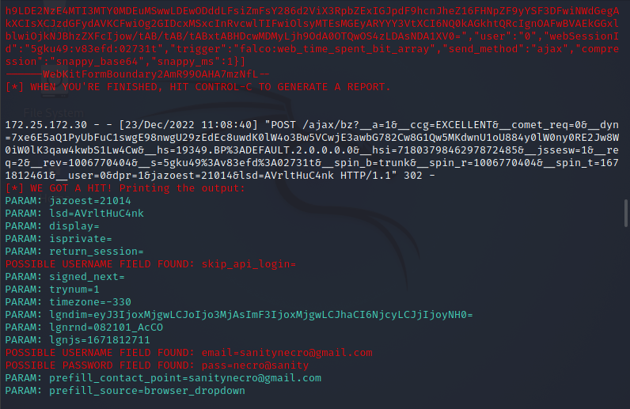

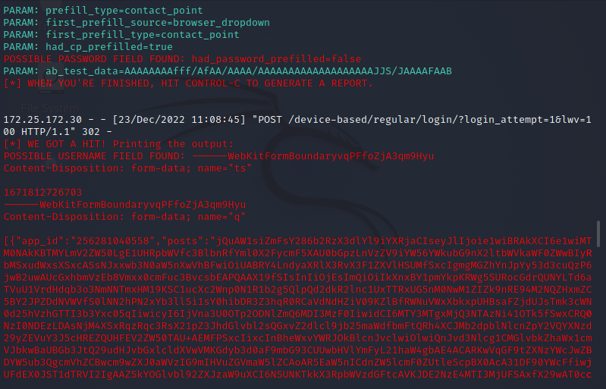

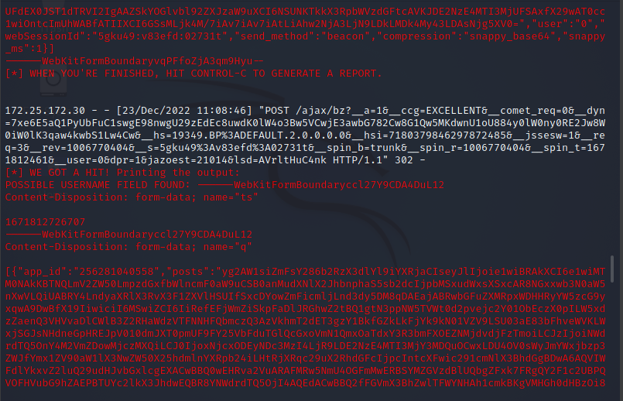

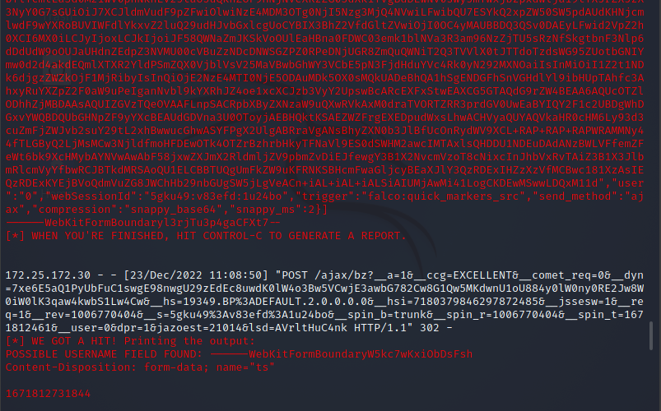

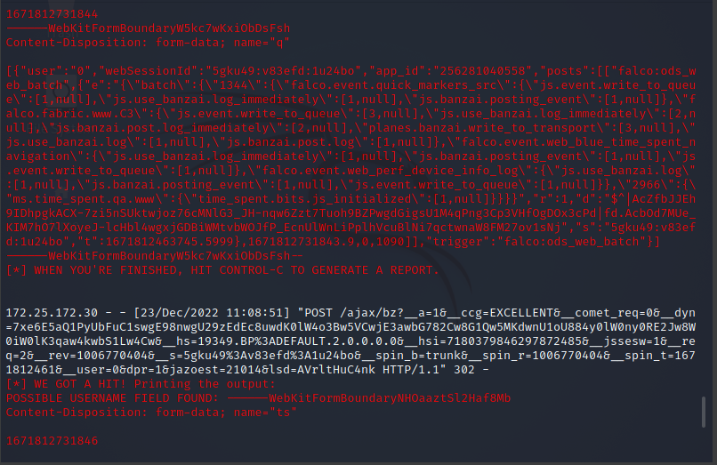

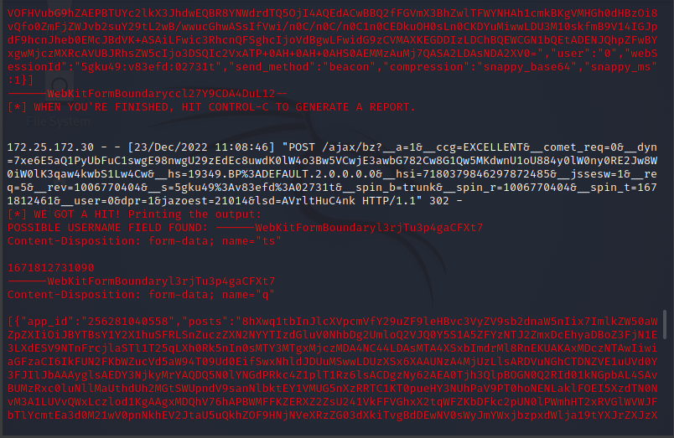

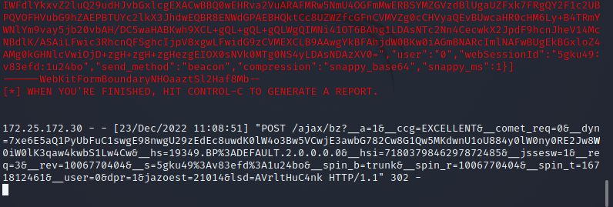

**Harvest:**

**UserName:-** [**sanitynecro231@gmail.com**](mailto:sanitynecro231@gmail.com)

**Passwd:- necro@sanity**

**What is social engineering**

Social engineering is the term used for a broad range of malicious activities accomplished through human interactions. It uses psychological manipulation to trick users into making security mistakes or giving away sensitive information.

Social engineering attacks happen in one or more steps. A perpetrator first investigates the intended victim to gather necessary background information, such as potential points of entry and weak security protocols, needed to proceed with the attack. Then, the attacker moves to gain the victim’s trust and provide stimuli for subsequent actions that break security practices, such as revealing sensitive information or granting access to critical resources.

What makes social engineering especially dangerous is that it relies on human error, rather than vulnerabilities in software and operating systems. Mistakes made by legitimate users are much less predictable, making them harder to identify and thwart than a malware-based intrusion.

**Social engineering attack techniques**

Social engineering attacks come in many different forms and can be performed anywhere where human interaction is involved. The following are the five most common forms of digital social engineering assaults.

**Baiting**

As its name implies, baiting attacks use a false promise to pique a victim’s greed or curiosity. They lure users into a trap that steals their personal information or inflicts their systems with malware.

The most reviled form of baiting uses physical media to disperse malware. For example, attackers leave the bait—typically malware-infected flash drives—in conspicuous areas where potential victims are certain to see them (e.g., bathrooms, elevators, the parking lot of a targeted company). The bait has an authentic look to it, such as a label presenting it as the company’s payroll list.

Victims pick up the bait out of curiosity and insert it into a work or home computer, resulting in automatic malware installation on the system.

Baiting scams don’t necessarily have to be carried out in the physical world. Online forms of baiting consist of enticing ads that lead to malicious sites or that encourage users to download a malware-infected application.

**Scareware**

Scareware involves victims being bombarded with false alarms and fictitious threats. Users are deceived to think their system is infected with malware, prompting them to install software that has no real benefit (other than for the perpetrator) or is malware itself. Scareware is also referred to as deception software, rogue scanner software and fraudware.

A common scareware example is the legitimate-looking popup banners appearing in your browser while surfing the web, displaying such text such as, “Your computer may be infected with harmful spyware programs.” It either offers to install the tool (often malware-infected) for you, or will direct you to a malicious site where your computer becomes infected.

Scareware is also distributed via spam email that doles out bogus warnings, or makes offers for users to buy worthless/harmful services.

**Pretexting**

Here an attacker obtains information through a series of cleverly crafted lies. The scam is often initiated by a perpetrator pretending to need sensitive information from a victim so as to perform a critical task.

The attacker usually starts by establishing trust with their victim by impersonating co-workers, police, bank and tax officials, or other persons who have right-to-know authority. The pretexter asks questions that are ostensibly required to confirm the victim’s identity, through which they gather important personal data.

All sorts of pertinent information and records is gathered using this scam, such as social security numbers, personal addresses and phone numbers, phone records, staff vacation dates, bank records and even security information related to a physical plant.

**Phishing**

As one of the most popular social engineering attack types, phishing scams are email and text message campaigns aimed at creating a sense of urgency, curiosity or fear in victims. It then prods them into revealing sensitive information, clicking on links to malicious websites, or opening attachments that contain malware.

An example is an email sent to users of an online service that alerts them of a policy violation requiring immediate action on their part, such as a required password change. It includes a link to an illegitimate website—nearly identical in appearance to its legitimate version—prompting the unsuspecting user to enter their current credentials and new password. Upon form submittal the information is sent to the attacker.

Given that identical, or near-identical, messages are sent to all users in phishing campaigns, detecting and blocking them are much easier for mail servers having access to threat sharing platforms.

**Spear phishing**

This is a more targeted version of the phishing scam whereby an attacker chooses specific individuals or enterprises. They then tailor their messages based on characteristics, job positions, and contacts belonging to their victims to make their attack less conspicuous. Spear phishing requires much more effort on behalf of the perpetrator and may take weeks and months to pull off. They’re much harder to detect and have better success rates if done skillfully.

A spear phishing scenario might involve an attacker who, in impersonating an organization’s IT consultant, sends an email to one or more employees. It’s worded and signed exactly as the consultant normally does, thereby deceiving recipients into thinking it’s an authentic message. The message prompts recipients to change their password and provides them with a link that redirects them to a malicious page where the attacker now captures their credentials.

**Social engineering prevention**

Social engineers manipulate human feelings, such as curiosity or fear, to carry out schemes and draw victims into their traps. Therefore, be wary whenever you feel alarmed by an email, attracted to an offer displayed on a website, or when you come across stray digital media lying about. Being alert can help you protect yourself against most social engineering attacks taking place in the digital realm.

Moreover, the following tips can help improve your vigilance in relation to social engineering hacks.

1. Don’t open emails and attachments from suspicious sources – If you don’t know the sender in question, you don’t need to answer an email. Even if you do know them and are suspicious about their message, cross-check and confirm the news from other sources, such as via telephone or directly from a service provider’s site. Remember that email addresses are spoofed all of the time; even an email purportedly coming from a trusted source may have actually been initiated by an attacker.
2. Use multifactor authentication – One of the most valuable pieces of information attackers seek are user credentials. Using multifactor authentication helps ensure your account’s protection in the event of system compromise. Imperva Login Protect is an easy-to-deploy 2FA solution that can increase account security for your applications.
3. Be wary of tempting offers – If an offer sounds too enticing, think twice before accepting it as fact. Googling the topic can help you quickly determine whether you’re dealing with a legitimate offer or a trap.
4. Keep your antivirus/antimalware software updated – Make sure automatic updates are engaged, or make it a habit to download the latest signatures first thing each day. Periodically check to make sure that the updates have been applied, and scan your system for possible infections.